User Guide of New Tracer

Walter Xie

11/06/10

The new function of tracer allows analyzing values in 3 different trace types:

* Real (R) is double,
* Integer (I) is integer,
* Category (C) is string.

1. Define Trace Type in Log File

The real (R) type is default. For other two types, the user needs to define in the top comment section of given log files. The format starts at keyword, *integer* or *category*, and follows by the set of trace names to be defined as this type, which are delimited by tab. For example:

# … …

# category index1 index2

# integer index3 index4

state posterior … index1 index2 index3 index4

0 -18107.89569 … A B 0 0

5000 -11757.36321 … C C 2 2

10000 -11682.44755 … C A 2 2

15000 -11652.15645 … C A 2 1

… …

1. New Plot and Table on Joint-Marginal Panel

Go to **Joint-Marginal** panel and choose two traces in **Statistic** table on the left side, if their trace types are both discrete (*integer* or *category*), then a probability table will replace the plot. It also provides calculations for the marginal, joint, conditional probability and frequency count.

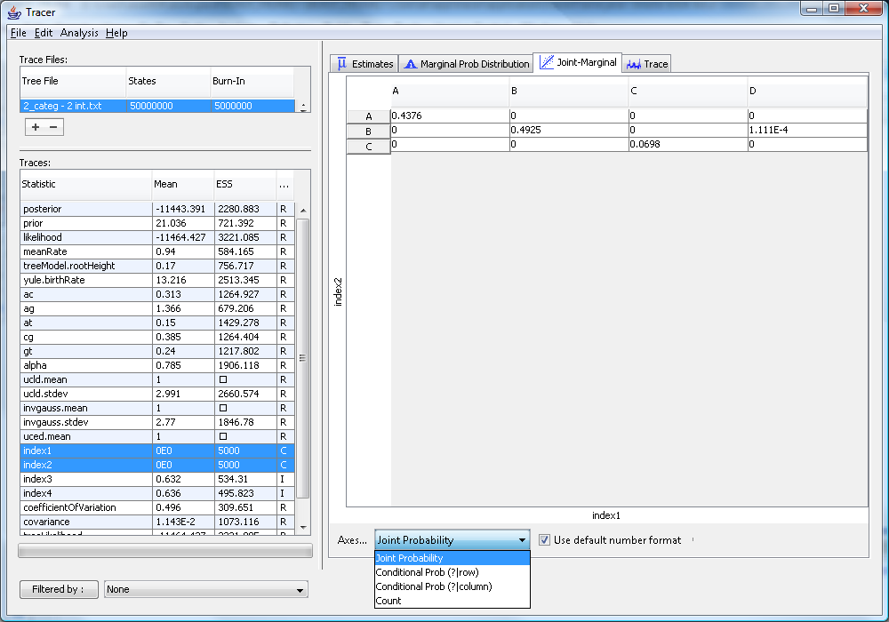

1. Filter

Each file can have one trace filtered by either selecting values if it is discrete (*integer* or *category* type) or selecting values in a range if it is continuous (*real* type). For example,

* Choose trace to be filtered from drop list on the bottom;

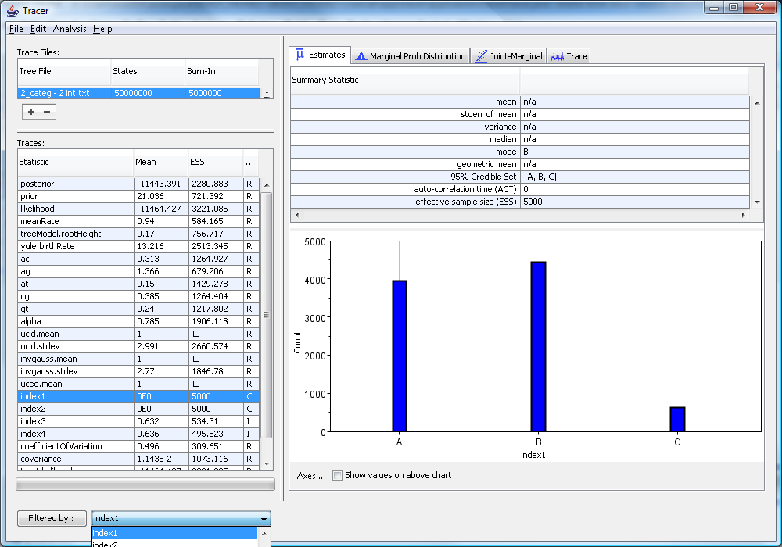

* Click “Filtered by:” button to pop up “Create A Filter” dialog, and select the value(s) which you are going to keep in the following analysis, and then click “Apply Filter”;

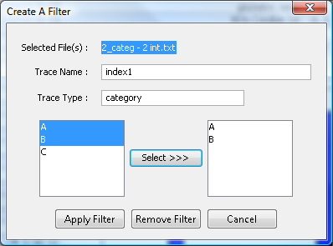

* As it can be seen, trace **index1** only shows its value **A** and **B**. In fact, only the state whose trace **index1** contains value **A** or **B** is allowed to participate in the following analysis, and the analysis result is recalculated based on these states whose trace **index1** contains value **C** are filtered out.

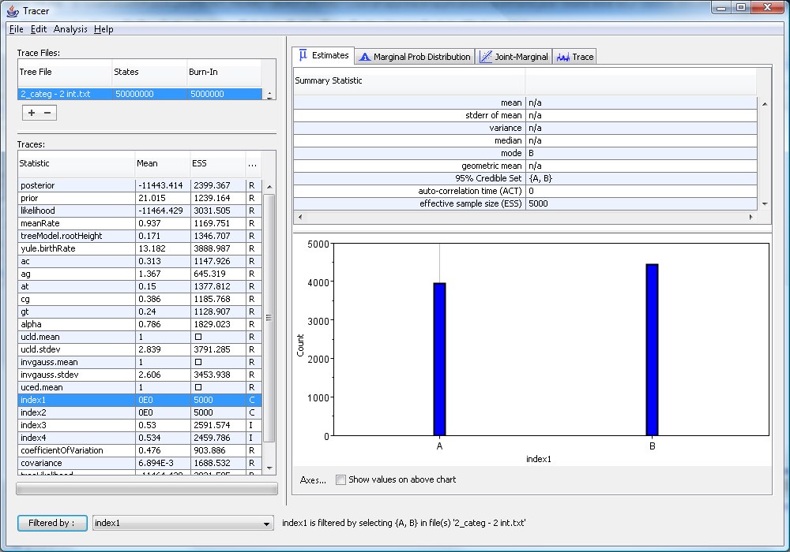

* Though each file allows only one filter applied, many other filters are stored in its corresponding trace. To use it, the user needs to select the corresponding trace name in the drop list and repeat above processes to apply new filter. And then, the previous filter will be replace by this new filter;

* If user wants to remove the applied filter of selecting file, the correct trace name applying filter has to be selected in the drop list, which is **index1** in this demonstration. Click “Filtered by:” button to get “Create A Filter” dialog, and then click “Remove Filter”. This selecting file will have no filter, but the rest of storing filter configurations are kept;
* If user wants to remove the applied filter and all stored configurations, “None” in the top of drop list has to be selected. Click “Filtered by:” button to remove all filters.

Everything regarding filter status of selecting files can be found in the message bar on the bottom right of the frame.